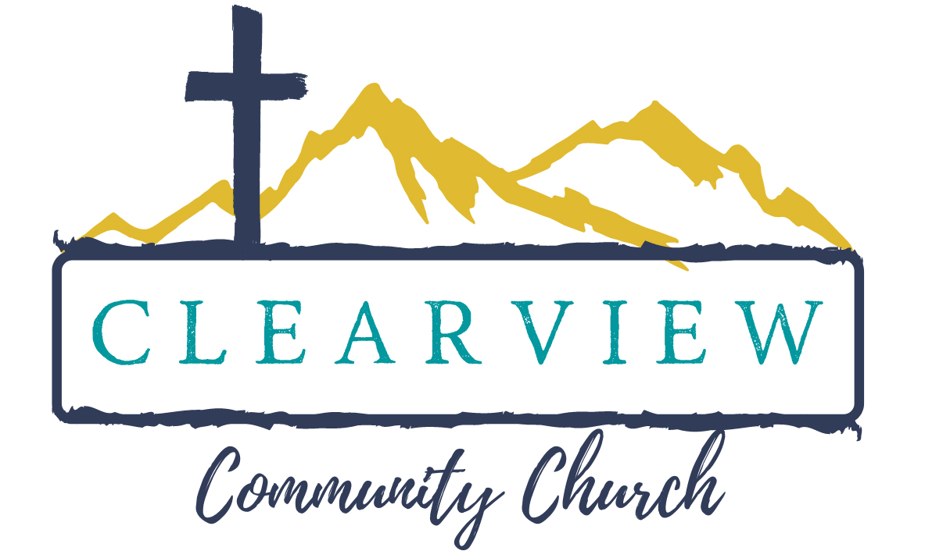

ClearView 101

Beliefs and Tenets of ClearView Community Church

“In the essentials, unity,
In the nonessentials, liberty,
In all things, charity (love)” . . . Rupertus Meldenius

All Scripture is self-attesting and, being Truth, requires our unreserved submission in all areas of life. The infallible Word of God, the sixty-six books of the Old and New Testaments, is a complete and unified witness to God’s redemptive acts, culminating in the incarnation of the living Word, the Lord Jesus Christ. The Bible, uniquely and fully inspired by the Holy Spirit, is the sole, supreme, and final source and authority on all matters concerning truth, morality, and the proper conduct of mankind.

1. We believe in one God, the sovereign Creator and Sustainer of all things, infinitely perfect and eternally existent in three Persons: Father, Son, and Holy Spirit.
To Him be all honor, glory, and praise forever!

2. Jesus Christ, the living Word became flesh by the Holy Spirit, through the miraculous virgin conception and birth. He who is true God became true man united in one Person forever. He died on the cross as a sacrifice for our sins according to the Scriptures. On the third day, He arose bodily from the dead, was seen by many witnesses, and ascended into heaven, where now, at the right hand of the Majesty on High, He is our High Priest and Mediator.

3. The Hoy Spirit has come to glorify Christ and to apply the saving work of Christ to our hearts. He convicts us of sin and draws us to the Savior. Indwelling our hearts, He gives us new life, imparting gifts to and empowering us for service in His Kingdom. He instructs and guides us into all truth, and seals us for the day of redemption.

4. Being estranged from God and condemned by our sinfulness, our salvation is wholly dependent upon the work of God’s free grace. God credits His righteousness to those who put their faith in Christ alone for their salvation, and thereby justifies them in His sight. Only such as are born of the Holy Spirit and receive Jesus Christ become children of God and heirs of eternal life.

5. The true Church is composed of all persons who, through saving faith in Jesus Christ and the sanctifying work of the Holy Spirit, are united together in the body of Christ. The Church finds her visible, yet imperfect, expression in local congregations where the word of God is preached in its purity, scriptural discipline is practiced, and loving fellowship is maintained. For her perfecting, she awaits the return of her Lord.

6. Jesus Christ will come again to the earth-personally, visibly, and bodily-to judge the living and the dead, and to consummate history and the eternal plan of God.
“Even so, come, Lord Jesus.” Revelations 22:20

7. The Lord Jesus Christ commands all believers to proclaim the Gospel throughout the world and to make disciples of all nations. Obedience to the Great Commission requires total commitment to “Him who loved us and gave Himself for us.” He calls us to a life of self-denying love and service.
“For we are His workmanship, created
in Christ Jesus for good works, which God prepared
beforehand that we should walk in them.” Ephesians 2:10

We are unified in our commitment to the essentials of the historic Christian faith taught in the Bible, but allow liberty of conscience on those matters which are not evident in, or central to, the Bible’s teaching.

1. Life: We believe that all human life is sacred and created by God in His image. Human life is of inestimable worth in all its dimensions, including pre-born babies, the aged, the physically or mentally challenged, and any other stage or condition from birth through natural death. We are therefore called to defend, protect, and value all human life.
“You made all the delicate, inner parts of my body and knit me together in my mother’s womb.
Thank you for making me so wonderfully complex!
Your workmanship is marvelous—how well I know it.
You watched me as I was being formed in utter seclusion,
as I was woven together in the dark of the womb.
You saw me before I was born.
Every day of my life was recorded in your book.
Every moment was laid out before a single day had passed.” Psalm 139:13-16

2. Marriage: We believe that God wonderfully and immutably creates each person as male or female. These two distinct, complementary genders together reflect the image and nature of God. Rejection of one’s biological sex is a rejection of the image of God within that person. We believe that the term ”marriage” has only one meaning: the uniting of one man and one woman in a single, exclusive union, as delineated in Scripture.
“So God created mankind in His own image, in the image of God He created them;
male and female he created them.” Genesis 1:27
“But for Adam no suitable helper was found. So the Lord God caused the man to fall into a deep sleep; and while he was sleeping, He took one of the man’s ribs and then closed up the place with flesh. Then the Lord god made a woman from the rib he had taken out of the man, and he brought her to the men. The man said, ‘This is now bone of my bones and flesh of my flesh; she shall be called woman, for she was taken out of man. That is why a man leaves his father and mother and is united to his wife, and they become one flesh. Adam and his wife were both naked, and they felt no shame.”
Genesis 2:18-25

3. Baptism: We believe in New Testament baptism, in the name of the Father, the Son, and the Holy Spirit. It is an act of obedience symbolizing the believer’s faith in the crucified, buried, and risen Savior, the believer’s death to sin, the burial of the old life, and the resurrection to newness of life in Christ Jesus. It is a testimony to the believer’s faith in the final resurrection of the dead. It is not necessary for salvation.

4. Communion: The Lord’s Supper is a symbolic act of obedience by believers. Partaking of the bread and the cup as symbols of Christ’s body and blood memorializes the death of the Redeemer and anticipates His second coming.

5. Worship in Music: Music is one of the powerful ways we express worship to God and pronounce our faith in Him. Our goal is for the people of God, in all their diversity, to join together to glorify God through the offering up of corporate praise. The heart of the worship teams is to artfully weave together varying musical styles and other elements into a seamless tapestry that honors the Lord without alienating any particular person or group.

6. Leadership: ClearView Community Church is led by a plurality of lay leaders with different functions and callings. We believe leadership is a call to serve, not to rule over others. Jesus Christ is our example. We realize that without God’s power, given to us through the Holy Spirit, we cannot, as His people, make any lasting change.

Elder Board: The function of the Elder board is to shepherd and lead the church in direction and spiritual oversight. For purposes of ClearView Community Church’s faith, doctrine, practice, policy, and discipline, our Elder board is the final interpretive authority on the Bible’s meaning and application.

Administration Team: The Administration team coordinates all matters pertaining to the collection and disbursement of funds, ordering financial planning and accountability of the church as means to facilitate ministry. They also coordinate personnel issues, including, but not limited to, hiring, policies, staff reviews, and maintenance of staff records.

Congregational Participation: The Pastoral, Elder, and Administrative teams seek transparency and honesty in the spiritual and financial business of ClearView as it is appropriate to do so. Necessary communication as it affects the body is given from the pulpit and in written communication. A Congregational vote is conducted to receive and accept the annual budget. Additional Congregational votes are required for hiring and dismissal of Lead Pastors.

7. Ministries:

Board of Deacons: The ministry of Deacons, overseen by the Associate Pastor, is to be the hands and feet of Jesus Christ, giving practical care and service to those in need.

Care Ministry: The Care Ministry ministers to the emotional, physical, and spiritual needs of hurting individuals in the body of Christ. They do not act as counselors, but care for others as empathetic listeners. Overseen by the Associate Pastor, every ClearView attendee has opportunity for involvement, whether it is to help someone move or care for an elderly person.

Hospitality: There is opportunity for involvement in many areas of the ongoing life of ClearView.
- Welcome ministry: Greeters, Ushers, and Information Center volunteers ensure all regular and visiting worshipers are welcomed into the body on Sunday morning.
- Hospitality: Volunteers assist in setting up communion, organizing memorial service and funeral meals, and setting up the Fellowship area for specific events.

Children and Youth Ministries: (led and coordinated by Staff Directors)
- Nursery: 9:00 am and 10:45 am Sundays: Staffed by trained volunteers, the nursery provides a fun, Christ-centered environment for the littlest ClearView attendees (0-3years old). It is also available for specified ministry functions other times during the week.
- Greenhouse: 9:00 am Sundays: Greenhouse provides an environment for children to grow in their faith together as they worship and learn. Trained volunteer teachers provide lessons and activities that keep Pre-schoolers through fifth graders coming back week after week.
- Vacation Bible School: One week of pure Christ-centered fun is offered each summer to 4year olds through 5th graders. In-coming 6th graders have a special opportunity to meet and bond before entering middle school.
- LiNK: Led by Directors and volunteer leaders, LiNK is a ministry for students in 6th through 8th grade. The purpose is to nurture a generation that desires to reunite themselves with a God who loves them. Teaching centers around the Biblical examples of who Jesus was and is; that He is the only LiNK to bringing each of us closer to God, and that He desires to have a relationship with each one. Camps and mission projects are available.
- Varsity: Led by Directors and volunteer leaders, Varsity is a ministry for 9th through 12th graders. Its focus is on further maturity and development of each student’s relationship with Jesus, with others, and with the world around them as they apply the Biblically based teachings. Camps, mission trips, and other events are available.

Adult Ministries: ClearView has many ministries for adults that are coordinated by Staff and lay leaders. The weekly ClearView announcements and bulletin can be used to keep up with the current and varied opportunities.
- Men: Prayer lunches, accountability groups, service events and projects, outreach events, retreats, and Bible studies are just some of the opportunities for men to deepen their walk with Christ and join Him in the work He is doing in the world.
- Women: Bible studies, mentoring, retreats, dinners, young mother’s groups, and meal ministry are a few of the opportunities that the Women’s Ministry offers.
- Small Groups: Coordinated by lay volunteers, there are groups meeting in which EVERYONE can get involved, regardless off age or circumstances. Developing a deeper walk with Christ and deeper fellowship with one another, and joining God is His Kingdome work, is the goal of these groups. There are specific and group-wide opportunities to participate in service projects and missions.
- Other opportunities: Bible studies, Adult Sunday classes, and topical classes are offered at various times throughout the year.

Missions: Since its beginning, ClearView has been dedicated to supporting local, national, and international missionaries. The teaching to “go out into all the world” is emphasized, from our youngest Greenhouse classes to the church as a body. There is opportunity to support many different missionaries and missions both financially, through “hands-on” mission projects, and trip opportunities.

Outreach to others in this body, or in the community, is a major expression of our faith in Jesus, and recognition of His ministry to each of us. By supporting families who have lost loved ones, had a new birth or adoption, are unable to get to worship.( . .the list is endless!), we become His hands and feet.

Special Needs: There is reserved seating in the sanctuary and assisted hearing devices available at all worship services.

WE ARE EXCITED TO HAVE YOU HERE AND INVITE YOUR INVOLVEMENT!

JOIN US AS WE
PRAY: The Bible tells us to “pray without ceasing” (1 Thessalonians 5:17). Prayer is one of the most powerful ministries of the body of Christ, and God does great things when we gather as a body in prayer. ClearView has a daily prayer e-mail for all those who wish to receive it. Please let the office know if you would like to be included. Corporate prayer opportunities are also available on Sundays and throughout the week.

LEARN: We believe that following Christ is about change. God wants to give us new perspectives and new hearts through His Word. As we understand His Word more and more, He will change us and let us know where He is at work, and how we can join Him. The opportunities at ClearView to receive this understanding are many.

CONNECT: Living a meaningful. Spirit-filled life cannot be done alone. God created us to live, grow, and thrive in community. We recognize that we need others to walk alongside. Sharing life within one of the many ministry opportunities is a way to start a deepening relationship with another person, and allow Christ to do His transforming work.

GIVE: Prayerfully consider giving financially to this ministry, as the Lord might lead. It is one of the many ways in which to give of oneself, so that ClearView can continue to give itself away in the service of our Lord, Jesus Christ.
“A generous man will prosper; he who refreshes others will himself be refreshed” Proverbs 11:25

We have found, as a group of Christ-followers, that the life of Christ
is very powerful and fulfilling when we are living an active, hands-on faith.
We invite you to join the journey!!

REV 11.2.17

